Agile Tester examination

Our company is currently developing a simple application that can retrieve all important information from the operating system and insert it into an archive file.

### The application:

* is an executable file (.exe) that needs to be run on given operating system,
* must be run with elevated user rights (as administrator)
* does not function in safe mode
* supports all operating systems from Windows 2000 and later (desktop as well as server)
* values of Logs age limit can be *1, 5, 30* or *60* (by default, *30*)
* supports these archive files (Logs collection mode) – *Filtered XML*, *Filtered binary* or *Original binary from disk* (default value is *Filtered binary*)

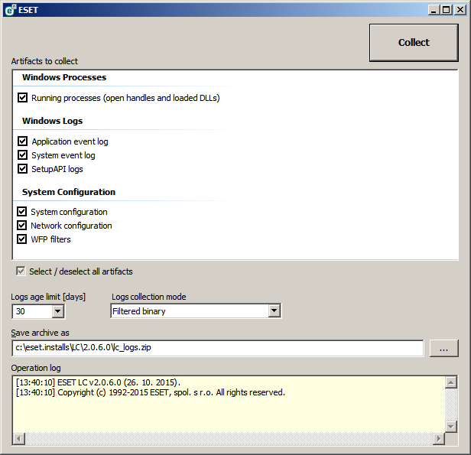

### Operation:

1. Run the *logcollector.exe* file.
2. Select the appropriate check boxes for the logs that you want to collect. If you are unsure what to select, leave all check boxes selected (all selected by default).
3. Specify the location where you want to save the archive file (by default, it is the path where the application is started from). The archive file name is already predefined.
4. Click **Collect**.
5. During the collection, you can view the operation log window at the bottom to see what operation is currently in progress. At the end, if the collection was successful, the archive file has been saved in the location specified.

# TASKS:

1. Due to other more important tasks to be done, your manager gives you 4 hours only to test if whether the application works as expected.   
   What would you do and why within the given time? Describe your test approach, how and why you select test environments, test data, test cases, etc…
2. Your next goal is to design and prepare automated tests to examine the application.  
   Create a documentation where you describe your automation approach and prepare particular automated tests (provide either source code or pseudo-code for these tests).  
   **Note:** the time limitation from task 1 above does not apply to task 2!